TOOLKIT DOCUMENT FOR GO

1. Title & Objective

Title : Getting Started with Go for Backend Development: A Beginner's Toolkit

- What technology did you choose? - I chose Go (Golang), an open-source programming language supported by Google.

- Why did you choose it? - I wanted to learn a systems language that is famous for its speed and simplicity. Go is highly relevant for modern cloud infrastructure (Docker) and high-performance backends (Uber,), making it a valuable skill for employability.

- What's the end goal? - The goal is to understand the basics of Go's syntax and strict typing, and then build and run a minimal JSON API server that creates a structured HTTP response.

2. Quick Summary of the Technology

- What is Go? - Go is an open-source programming language supported by Google. It is statically typed and compiled, making it extremely fast. It was designed to be simple, efficient, and reliable, specifically for building large-scale software systems.

- Where is it used? - It is widely used for:

- Backend Web Development: Building APIs and Microservices.
- Cloud & Infrastructure: Tools like Docker and Kubernetes are written in Go.
- Command Line Tools: CLI applications.

- Real-world Example - Uber uses Go for many of its high-performance microservices like their geofencing service because of its speed and ability to handle thousands of concurrent connections efficiently.

3. System Requirements

- Operating System: macOS, Linux, or Windows.

- Tools:
- VS Code(Recommended Editor).
- Go Extension for VS Code (by the Go Team at Google).
- Packages: No external package manager like `npm` is needed initially; Go includes its own toolchain (`go mod`).

4. Installation & Setup Instructions

- Step 1: Install Go

On Windows (using Homebrew):

brew install go

Alternatively (Download): Visit [go.dev/dl](https://go.dev/dl/) and download the package for your operating system.

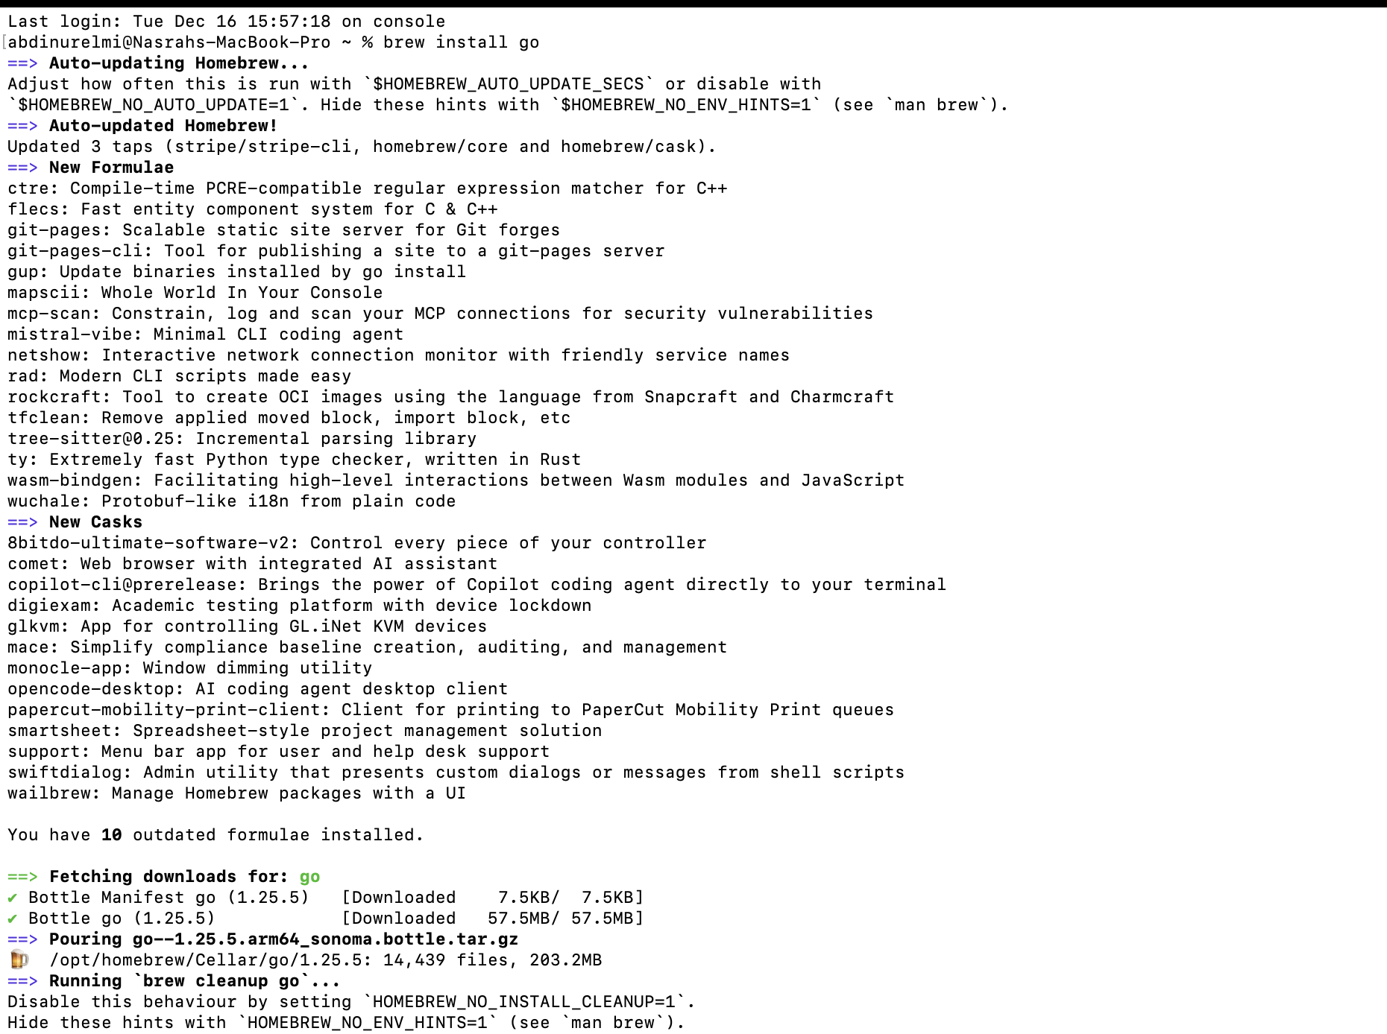
Figure 1:Image showing the installation of Go in the terminal

- Step 2: Verify Installation

Open your terminal and run:

go version

Output should look like: go version go1.21.0 darwin/arm64

Figure 2:Image showing the checking of the version of Go installed

- Step 3: Setup VS Code

1. Open VS Code.
2. Press `Cmd+Shift+X` to open Extensions.
3. Search for "Go" and install the official extension by the Go Team at Google.

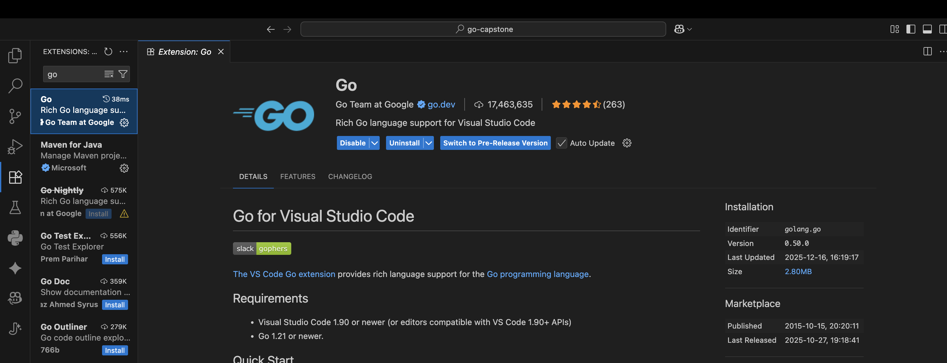
Figure 3:Image showing the installed Go extension on VSCode

5. Minimal Working Example (Walkthrough)

We will build a Tiny JSON API. This mimics a real-world backend service rather than just printing text.

The Code (‘main.go’)
package main

import (
"encoding/json"
"fmt"
"log"
"net/http"
"time"
)

// Response struct defines the shape of our JSON data
type Response struct {
Message string `json:"message"`
Timestamp time.Time `json:"timestamp"`
Language string `json:"language"`
}

func handler(w http.ResponseWriter, r *http.Request) {
// Set header so browser knows it's JSON
w.Header().Set("Content-Type", "application/json")

// Create data
data := Response{
Message: "Hello from Go!",
Timestamp: time.Now(),
Language: "Golang",
}

// Send data
json.NewEncoder(w).Encode(data)
}

func main() {
http.HandleFunc("/", handler)
fmt.Println("Server running at http://localhost:8080")
log.Fatal(http.ListenAndServe(":8080", nil))
}

How to Run It

1. Create a folder named ‘go-capstone’.
2. Run ‘go mod init go-capstone’ in terminal (creates ‘go.mod’).
3. Save the code above as ‘main.go’.
4. Run ‘go run main.go’.
5. Visit ‘http://localhost:8080’ in your browser.

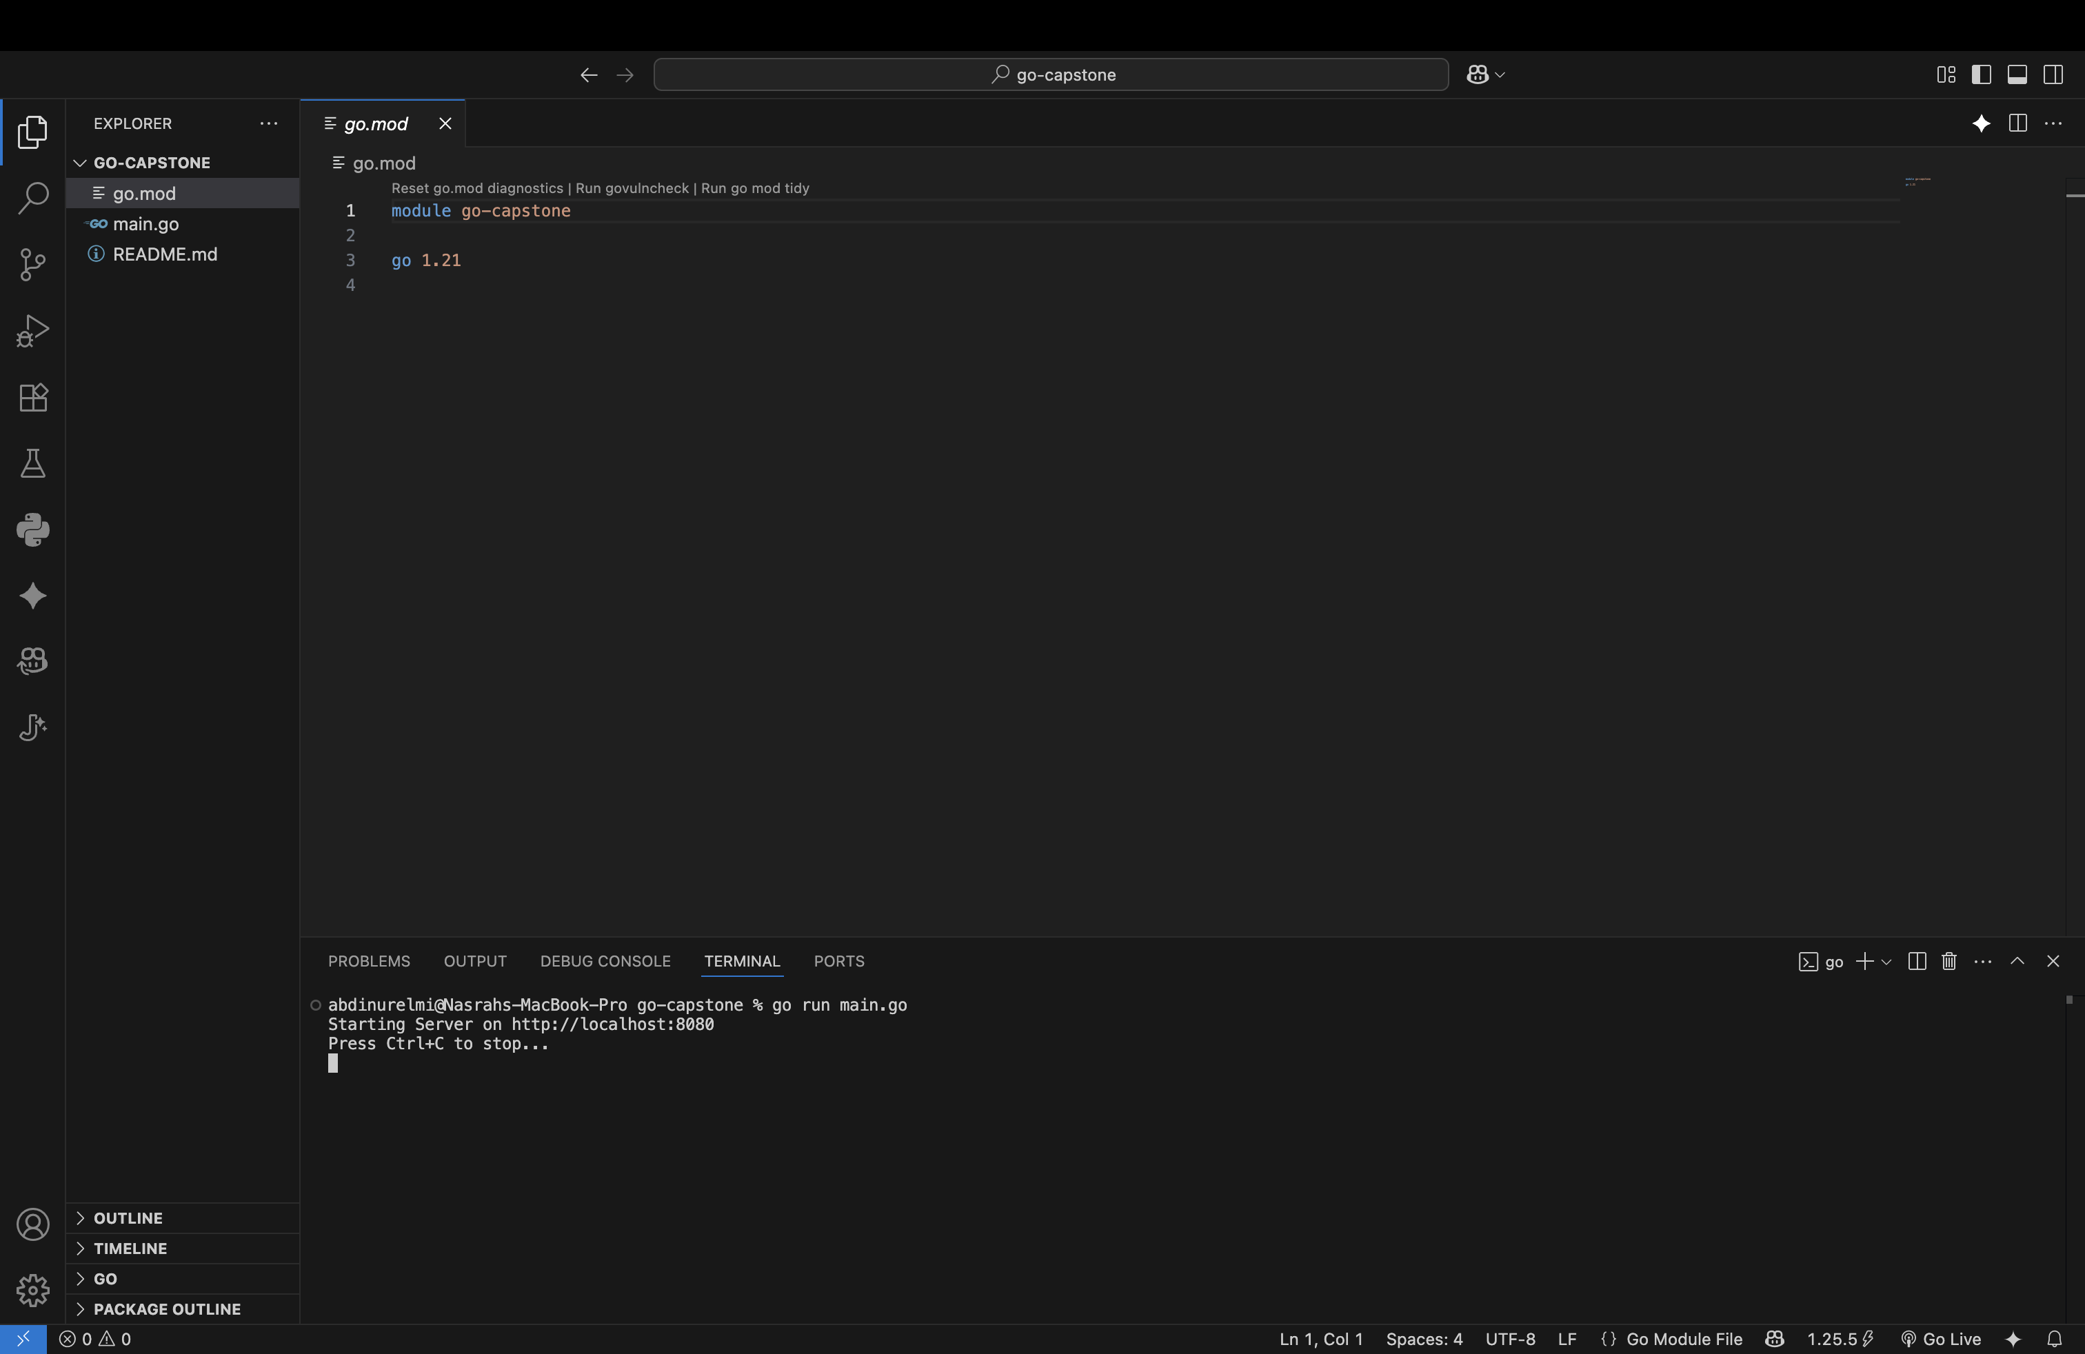
Figure 4:Image showing the running process of the program

Expected Output:
json
{"message":"Hello from Go!","timestamp":"2024-12-16T...","language":"Golang"}

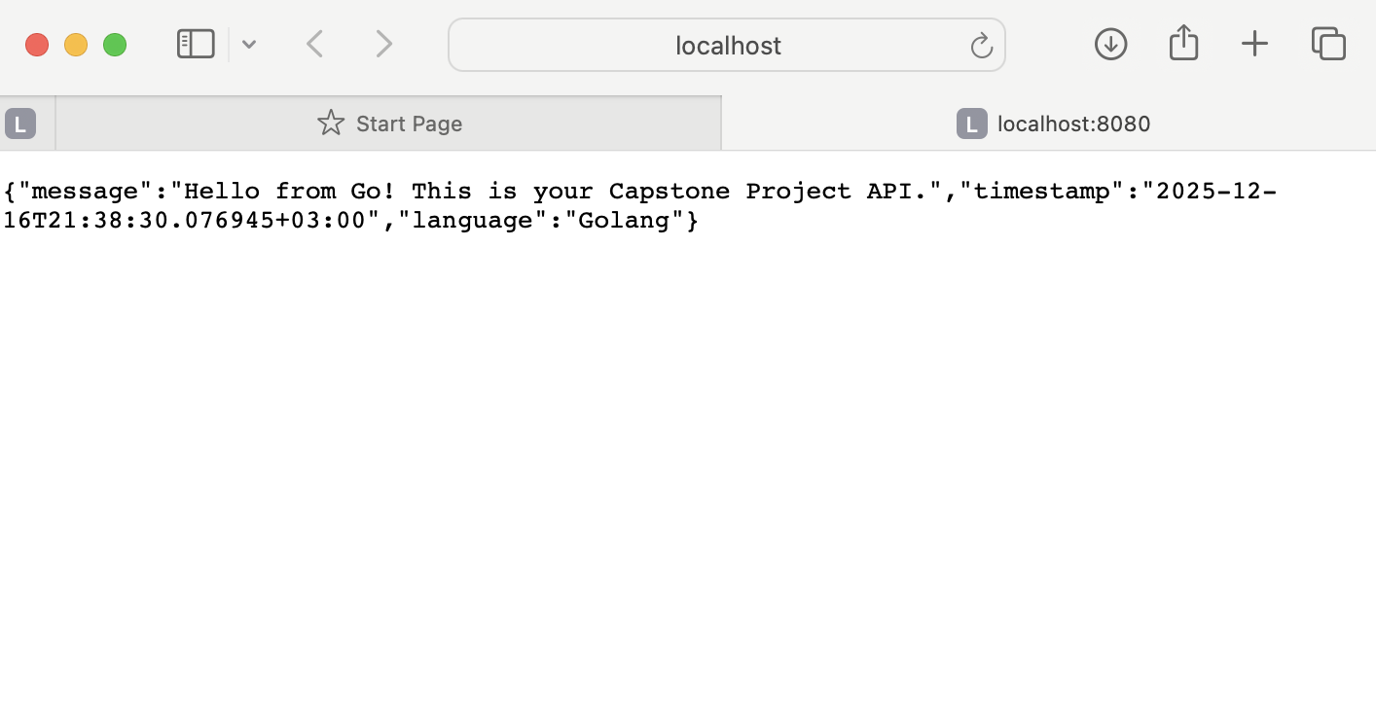
Figure 5:Image showing the output of the Go program

6. AI Prompt Journal

I used AI to accelerate my learning process. Here is the record of my prompts:

- Prompt 1: Understanding Changes

- Prompt used: "Explain how variables in Go differ from Python. Why do I see `msg := 'hello'` instead of just `msg = 'hello'`?"

- AI's response summary: The AI explained that Go is statically typed and `:=` is a shorthand operator that declares and initializes a variable with inferred type. It contrasted this with Python's dynamic typing.

- Evaluation of its helpfulness: Extremely helpful. It clarified why I was getting "undefined variable" errors when trying to use Python-style assignments.

- Prompt 2: Building the Server

- Prompt used: "Show me the simplest way to return JSON in a Go HTTP server without using external frameworks like Gin."

- AI's response summary: The AI provided a snippet using the standard library `net/http` and `encoding/json` packages. It showed how to define a `struct` with JSON tags.

- Evaluation of its helpfulness: High. It prevented me from over-engineering the solution with complex third-party tools for such a simple task.

Reflection
The strict typing of Go felt restrictive at first coming from dynamic languages, but the compiler catches so many errors (like typos in variable names) before the code even runs.

Testing And Iteration

The API was tested by running the server locally and accessing the endpoint through a browser at `localhost:8080`. Initial errors encountered during module initialization and JSON serialization (empty JSON output) were resolved through iterative debugging and reference to official documentation. The final response confirmed the server was correctly structuring and serving the data.

7. Common Errors & Fixes

- Issue: ‘go: cannot find main module’

- What didn't work: Running ‘go run main.go’ immediately after creating the file.

- Resolution: Run ‘go mod init go-capstone’ to initialize the project directly.

- Reference: [Go Modules Wiki](https://github.com/golang/go/wiki/Modules)

- Issue: Struct fields not appearing in JSON

- What didn't work: My JSON output was empty ‘{}’ even though I populated the data.

- Resolution: I learned that lower-case fields are private in Go. I had to capitalize ‘message’ to ‘Message’.

- Reference: [StackOverflow: json.Marshal returns empty object](https://stackoverflow.com/questions/11126793/json-marshal-returns-empty-body-with-basic-struct)

8. References

- [A Tour of Go](https://go.dev/tour/welcome/1) - Official interactive tutorial.

- [Go by Example](https://gobyexample.com/) - Great practical snippets.

- [Go 101](https://go101.org/) - Deep dive into details.

- [Learn Go in 12 Minutes (YouTube)](https://www.youtube.com/watch?v=C8LgvuEBraI) - A quick video overview.

